Use the comman:. .gps to get your location.
You should get information like this:
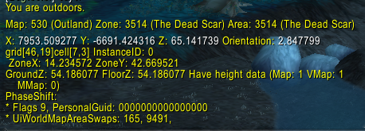

For fixing a wrong level of creatures in a zone you need the information of 1 and 2
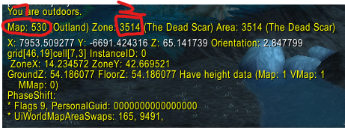

UPDATE creature_template_scaling ct
JOIN (
SELECT id FROM creature WHERE zoneId = 3514 AND map = 530
) c ON ct.Entry = c.id
SET LevelScalingMin = 2, LevelScalingMax = 61;

The in the zone in this example the starting level should be 2 and ending level should be 61.
In scaling avoid starting at LevelScalingMin = 1 and the LevelScalingMax 100 or 120.
Better use 103 and 123.
Each Region for example Silvermoon Forest has a lot of zones. It is never one big zone.

